Chamber of Commerce
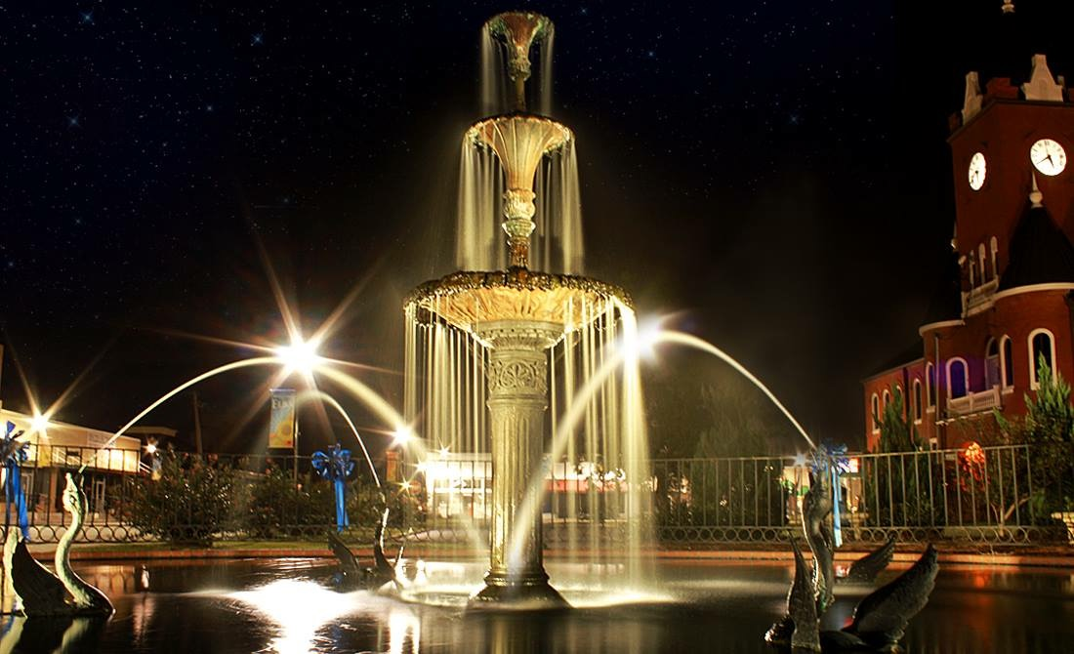
PROGRAM OF WORK 2017-2018
Our mission is to promote Elba and to represent business by providing leadership that supports the community and creates resources, education, networking opportunities and outreach for Elba.
As your Chamber, we speak for entrepreneurs and leaders in every business sector who share the common understanding that fostering a strong business climate is the key to Elba’s prosperity.
Our membership includes small and large businesses that offer products and services to customers locally and worldwide. We’re proud of our member firms and family businesses who trade throughout Elba and energize one of Alabama’s most historic cities.

Elba
vISIOn
Our vision for Elba is a destination where the community works, lives, and enjoys the arts, quality entertainment, outstanding restaurants, and delightful shopping experiences in the friendly unique small town atmosphere of Elba on the Pea River. It is a place where people desire to live in renovated residences and new up-scale dwellings. Property owners enjoy high occupancies rates and business owners prosper with the demand for their services and products. Those who work in Elba enjoy a real sense of place, community, and conveniences. Parents kiss their children goodbye at one of the first-rate day care centers and at our great city school system. They drop clothing at the dry cleaners, get in a 20-minute workout at the local gym, have coffee and breakfast before work. At the end of the day, they shop and pickup dinner at the shopping center, take children to dance lessons while they take yoga and art classes, they volunteer in the community garden or at their church, they visit with their friends and neighbors. They go out to eat and see a show at the theatre. They invite family and friends to visit Elba. They know that life is good.

The role of Chamber, Main Street, Visit Elba
The Chamber exists to foster development and stability through organization, promotion, design, and economic revitalization.
Primary services include:
- Commitment to Promoting Elba
- Assistance for Relocation
- Business Start-up
- Business Inventory
- Marketing
- Promotional Collateral
- Tourism Development
- Business Promotions and Events
- Assistance for revitalization
- Ribbon Cuttings
- Information and Tours
- Destination Wedding Packages

Chamber of Commerce and Main Street Elba Location
The Chamber of Commerce is in the historic Stinson House built in 1903.
Address: 329 Putnam Street, Elba, Alabama 36323
Hours: Monday through Friday, 8 a.m. to 5 p.m.
Phone: (334) 897-3125 Cell: (334) 790-908

Organization
The Elba Chamber of Commerce and Main Street is operated by a paid staff and is assisted by the city, the board, the committees and citizens. The executive director reports directly to the Elba Main Street Board of Directors and is responsible for managing the overall administration, programs, and resources.

The Main Street Board is comprised of community leaders with a passion for service. Board members serve multi-year terms.
Chairman of the Board – Justin Maddox
Vice Chairman – Neil Grantham
2nd Vice Chairman – Carrie Whitworth
Secretary – Denise Sauls
Treasurer – Rene Lambert
Past Chairman – Gappa Wise
Rhett McCollough
Kenya Martin
Lynn Kelley
Jerry Dubose
Bradley Bane
Tom Maddox
Michael Mosley
Josh Wilson
Linda Hodge
Joey Daniels

Board Duties
Board members determine future vision, establish governing policies, adopt advocacy positions, provide community leadership, assist in engagement, participate in events and monitor the operations.

Staff
The staff is responsible for the day-to-day operations. This includes the tasks necessary to develop resources and execute programs.
Executive Director - Sandy Bynum, APR

Events Scheduled for 2017-2018
Pumpkins on the Square – Halloween, October 31st
Elba opens its historic Court Square to celebrate Halloween. This year’s event will offer fun, food, entertainment, thrills, and fellowship. Area businesses, churches and organizations will be giving away candy for trick or treat; there will be a costume contest, and Haunted Hayride. All events are open to the public.
Elba’s Big Christmas Parade – First Monday in December
Santa arrives in Elba to kick-off the Christmas Shopping Season. The City, Chamber, and Main Street sponsor Elba's favorite tradition, the Christmas Parade. The parade signals the start of the Christmas season. Each year the parade attracts visitors to downtown to enjoy the decorations, narrated parade, socializing, and dining.

Eggs and Issues Legislative Breakfast – Second Friday in February
The Elba Chamber’s annual Legislative Breakfast provides the business community an opportunity to express ideas and suggestions to their Legislative delegation and to thank them for their service to the community. It also provides the opportunity to conduct a general discussion on key issues coming before them in the upcoming year that may impact Elba.

April Walking Tours- Each Saturday morning in April beginning at 10 a.m.
Elba rolls out our history with a one-hour walking tour of historic downtown. The tour begins at the Elba Chamber of Commerce. No charge.
Don’t Drop on Elba – Second week in April
With volunteers setting their times and locations throughout Elba and working to collect garbage, sort for recycling, remove invasive vegetation, spruce up the city, clean-up river-edge trail, plant native seedlings, and much more. April is clean-up, paint-up, fix-up time.
Let Freedom Ring– July 4
This Main Street award winning ole-fashioned get-together celebrates our country's independence as our founding fathers suggested with Parade featuring Uncle Sam, shows and entertainment, games, the ringing of church bells, and illuminations. Our citizens and guests come together in the heart of Court Square for an evening of family fun and an incredible firework show.
Annual Meeting Banquet – September
The Chamber of Commerce and Main Street hosts an annual gathering of business leaders that celebrate accomplishments of the previous year, honors outstanding businesses and individuals in the community and sets the tone for the coming year. The evening includes annual awards presentations and annual business meeting.
Participation
Participation in Chamber activities is completely optional. We're at work behind the scenes advocating on behalf of Elba whether you attend a single event. Many citizens do enjoy the ability to network, however. How much you do is up to you.

Sponsorship Opportunities
There are varieties of sponsorship opportunities available through the Chamber – everything from a primary sponsorship of a major event, to sponsoring a single occurrence or a special event.

Other Opportunities

Elba Chamber logo on marketing materials
You are welcome to display the logos on your marketing material, including your website. Request the logos and identity standards by emailing us elbachamber@troycable.net.
Brand Recognition
Elba is a friendly, easy-going city that invites all to embrace its traditions of history, heritage, culture, and natural resources and its vision to grow and prosper for the future.

